Homographs

🔹 What Are Homographs
# Source: Chatgpt (GPT-4-turbo) at [8/1/2025]
Homographs are words that are spelled the same but have different meanings — and they may have different pronunciations or the same.
From Greek: homo = same, graph = writing
So: “same spelling, different meaning”

🧱 Key Features of Homographs
# Source: Chatgpt (GPT-4-turbo) at [8/1/2025]
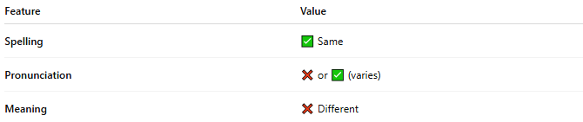
Feature | Value
Spelling | ✅ Same
Pronunciation | ❌ or ✅ (varies)
Meaning | ❌ Different

📝 Examples of Homographs
# Source: Chatgpt (GPT-4-turbo) at [8/1/2025]
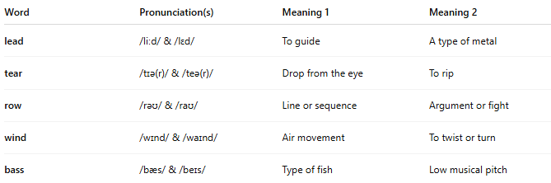
Word | Pronunciation(s) | Meaning 1 | Meaning 2
lead | /liːd/ & /lɛd/ | To guide | A type of metal
tear | /tɪə(r)/ & /teə(r)/ | Drop from the eye | To rip
row | /rəʊ/ & /raʊ/ | Line or sequence | Argument or fight
wind | /wɪnd/ & /waɪnd/ | Air movement | To twist or turn
bass | /bæs/ & /beɪs/ | Type of fish | Low musical pitch

📘 Types of Homographs
# Source: Chatgpt (GPT-4-turbo) at [8/1/2025]
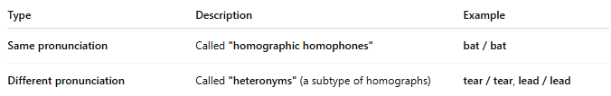
Type | Description | Example
Same pronunciation | Called "homographic homophones" | bat / bat
Different pronunciation | Called "heteronyms" (a subtype of homographs) | tear / tear, lead / lead

🧠 Why Are Homographs Important?
# Source: Chatgpt (GPT-4-turbo) at [8/1/2025]
- Cause ambiguity in reading, especially without context.
- Used in puns, wordplay, and poetic devices.
- Teach how context determines meaning.

🎨 Examples in Sentences
# Source: Chatgpt (GPT-4-turbo) at [8/1/2025]
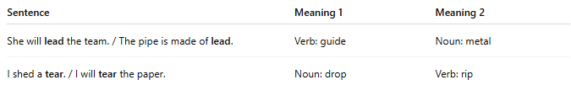
Sentence | Meaning 1 | Meaning 2
She will lead the team. / The pipe is made of lead. | Verb: guide | Noun: metal
I shed a tear. / I will tear the paper. | Noun: drop | Verb: rip

🧭 Comparison Table
# Source: Chatgpt (GPT-4-turbo) at [8/1/2025]
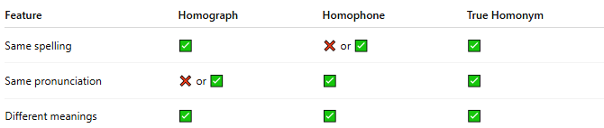
Feature | Homograph | Homophone | True Homonym
Same spelling | ✅ | ❌ or ✅ | ✅
Same pronunciation | ❌ or ✅ | ✅ | ✅
Different meanings | ✅ | ✅ | ✅

